Mrs. Soniya Sawant Dhore

Graphic / Ui / Visual / Web Designer

PERSONAL STATEMENT

I am 27 years old Artist & Freelance Designer from Talegaon Dabhade (PUNE). I love Website Design & I have 3 years 6 months of experience working as a freelance and working on a company also I love working with people, specially if they have the same passion

I have for what they do.

Why you hire me?

Please go further down to see the profile.

DESIGN SKILLS

COMPUTER

Adobe Photoshop

Adobe illustrator

CorelDraw

KNOWLEDGE

Grid & Layout

User Interface

Colour Combination

Sense for Typography

ADDRESS |  | CONTACT
Talegaon Dabhade |  | Call on: 9960 80 1301
Pune 410507 |  | soniya.alliswell@gmail.com
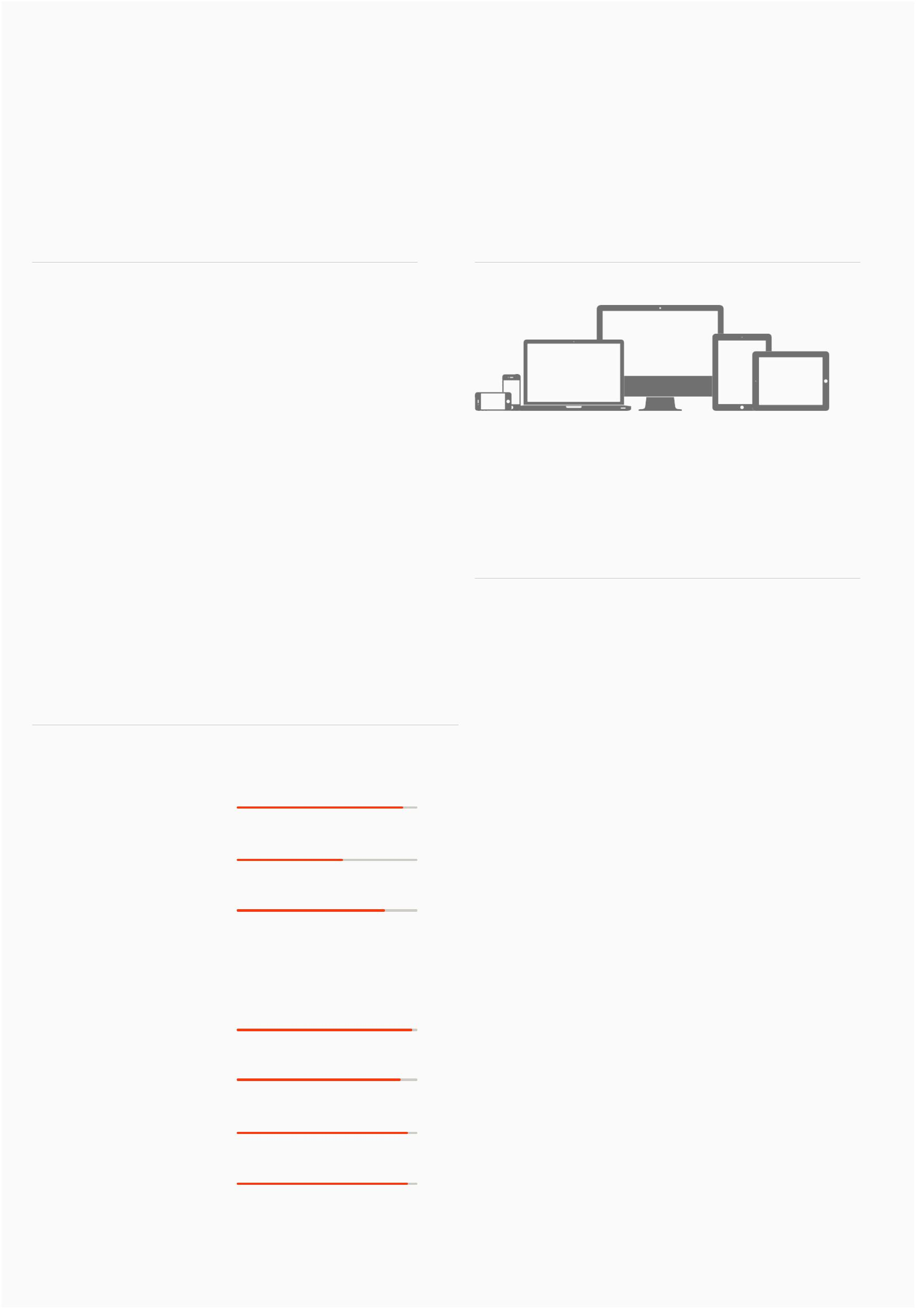

My SPECIALITIES

Responsive Website Design

EDUCATION

C-DAC, DACA COURSE

From February 2013 TO August 2013

College Name : Mumbai Educational Trust,

Bandra, Mumbai,

Maharashtra 400 050

PERCENTAGE : 61.89%

BACHELOR OF FINE ARTS

From 2008 TO August 2012

College Name : Dr. D.Y. Patil College of

Applied Arts, D. Y. Patil.

Educational Complex, Sector 29, Nigdi,

Pradhikaran, Akurdi, Pune 411044.

PERCENTAGE : FIRST CLASS

JUNIOR COLLEGE

S.N.D.T. Arts And Commerce College.

Kothrud near nal stop Pune.

PERCENTAGE : 56.33

Mrs. Soniya Sawant Dhore |  | ADDRESS |  |  | CONTACT
Graphic / Ui / Visual / Web Designer | Talegaon Dabhade |  |  |  | Call on: 9960 80 1301
Graphic / Ui / Visual / Web Designer |  | Pune 410507 |  |  | soniya.alliswell@gmail.com
WORK EXPERIENCE | Live Website Links

My total work experience is 3 years and 6 months. I have good knowledge of designing.

I Kanksha Pvt Ltd.

Job Description : Graphic / Ui Designer August 2013 to December 2013 Location : Pune.

CBIL360

Job Description : Web / Ui Designer

January 2014 to November 2014

Location : Pune.

KORU TECHNOLOGIES

Job Description : Web / Ui Designer

March 2015 to October 2015

Location : Pune.

FREELANCER

Job Description : Graphic /Web / Ui Designer November 2015 to till date

Location : Pune.

My Job Portfolio

CBIL 360

I designed multi-page website / Live projects in / Templates.

Gobiggi Application.

What is the Gobiggi application?

Gobiggi is the product of CBIL 360 company and this is online website builder application.

Live projects:

http://www.mdcacp.org/index.html

http://www.abrca.com/

http://www.beautifuliving.in/

http://www.rakeshjain.co.in/index.html

Some templates of gobiggi application. http://sites.gobiggi.com/Yacht/index.html http://sites.gobiggi.com/CMYK/ http://sites.gobiggi.com/WeddingMaker/Index.html http://sites.gobiggi.in/SpiceRestaurant/ http://sites.gobiggi.com/NailArtStudio/ http://sites.gobiggi.in/SmileCare/ http://sites.gobiggi.com/DrSophia/index.html http://sites.gobiggi.com/Glasses_Store/index.html http://sites.gobiggi.com/GlamourBeauty/

KORU Technologies

Responsible for hospital resource management application screens design as well as involved in designing a user interface for mobile and the web apps. I can't show my work portfolio because I had signed a non-disclosure agreement bond

with koru technologies.

Mrs. Soniya Sawant Dhore

Graphic / Ui / Visual / Web Designer

Live Website Links

As a Freelancer

I designed Logo Symbol, Corporate Branding, One page, Multi-pages websites.

Live projects:

http://www.mytenant.in/

http://www.vinayroses.com/

ADDRESS |  | CONTACT
Talegaon Dabhade |  | Call on: 9960 80 1301
Pune 410507 |  | soniya.alliswell@gmail.com
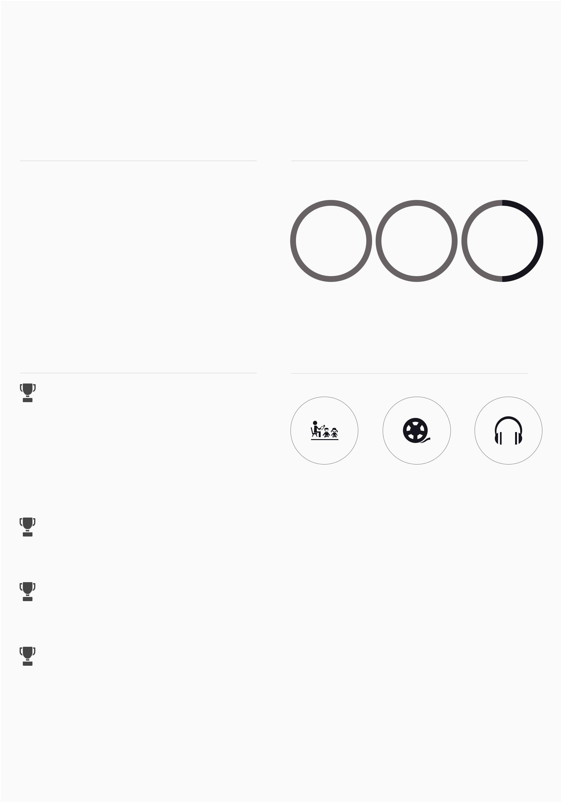

LANGUAGE

Marathi is my mother tongue.

MARARTHI HINDI ENGLISH

ACHIEVEMENTS INTERESTS & HOBBIES

LOGO SYMBOL DESIGN. ( 2013 )

I Won a 2nd prize for Right angle entertainment pvt. Ltd. Logo symbol design.

ACADEMIC ACHIEVEMENTS | TEACHING | MOVIE | MUSIC

S.N.D.T. ARTS & COMMERCE COLLEGE. (2005)

I got 2nd prize for poster design.

Dr. DY PATIL COLLEGE OF APPLIED ARTS. (2008)

I got 1st prize for 2D Design.

Dr. DY PATIL COLLEGE OF APPLIED ARTS. (2011)

I got 3rd prize for Photography.

